

Experiment - 7

Student Name: Chandan Kumar | UID: 23BAI70147
Branch: BE-AIT-CSE | Section/Group: 23AIT_KRG-G1_A
Semester: 5th | Date of Performance: 15 Oct, 2025
Subject Name: ADBMS | Subject Code: 23CSP-333

- Aim:
MEDIUM LEVEL PROBLEM:
Design a PostgreSQL trigger such that whenever an insertion occurs on the student table, the currently inserted or deleted row details (ID, Name, Age, Class) should be printed exactly as they are in the output console.

HARD LEVEL PROBLEM:
Design a PostgreSQL trigger system where:
      - When a new employee is inserted into tbl_employee, a record is added to tbl_employee_audit with the message:
“Employee name <emp_name> has been added at <current_time>”.
      - When an employee is deleted from tbl_employee, a record is added to tbl_employee_audit with the message:
“Employee name <emp_name> has been deleted at <current_time>”.

- Objective:
  - To understand the concept and working of triggers in PostgreSQL.
  - To learn how to create and implement trigger functions using PL/pgSQL.
  - To utilize OLD and NEW records for handling row data before and after triggering events.
  - To design automated auditing systems using triggers for data changes like INSERT and DELETE.

- Theory:

A trigger in PostgreSQL is a special function that is automatically executed or fired in response to certain events on a table or view. These events can be INSERT, UPDATE, DELETE, or TRUNCATE operations. Triggers help automate tasks, maintain data integrity, and perform complex business logic directly within the database.
In PostgreSQL, a trigger function is written in the PL/pgSQL language and is always associated with a table. The trigger function executes each time the specified event occurs on that table. There are two main types of triggers based on their timing: BEFORE triggers and AFTER triggers.

    - A BEFORE trigger executes before the event occurs and can be used to validate or modify data.
    - An AFTER trigger executes after the event has occurred and is often used for logging, auditing, or maintaining related tables.
Triggers can also be defined as ROW-level or STATEMENT-level. A ROW-level trigger fires once for each affected row, whereas a STATEMENT-level trigger executes once per SQL statement, regardless of how many rows are affected.

- Procedure:

Medium Level Solution:
    - Create or verify the student table with columns id (auto-generated), name, age, and class so the inserted row has an id available.
    - Write a PL/pgSQL trigger function fn_student_audit() that checks TG_OP and uses RAISE NOTICE to print NEW.* on INSERT and OLD.* on DELETE, returning NEW for INSERT and OLD for DELETE.
    - Create an AFTER trigger on student for INSERT OR DELETE, FOR EACH ROW, executing fn_student_audit() so a message is emitted for each affected row.
    - Test by inserting and deleting a row from student; ensure client_min_messages allows NOTICE to display in your client.

Hard Level Solution:
    - Create or verify the student table with columns id (auto-generated), name, age, and class so the inserted row has an id available.
    - Write a PL/pgSQL trigger function fn_student_audit() that checks TG_OP and uses RAISE NOTICE to print NEW.* on INSERT and OLD.* on DELETE, returning NEW for INSERT and OLD for DELETE.
    - Create an AFTER trigger on student for INSERT OR DELETE, FOR EACH ROW, executing fn_student_audit() so a message is emitted for each affected row.
    - Test by inserting and deleting a row from student; ensure client_min_messages allows NOTICE to display in your client.

- Code:

-----Experiment 7 (Medium Level Solution)-----
CREATE TABLE IF NOT EXISTS student ( id SERIAL PRIMARY KEY, name VARCHAR(100), age INT, class VARCHAR(20)
);

CREATE OR REPLACE FUNCTION fn_student_audit()
RETURNS TRIGGER
LANGUAGE plpgsql
AS $$
BEGIN
IF TG_OP = 'INSERT' THEN
RAISE NOTICE 'Inserted Row -> ID: %, Name: %, Age: %, Class: %',
NEW.id, NEW.name, NEW.age, NEW.class;
RETURN NEW;

ELSIF TG_OP = 'DELETE' THEN
RAISE NOTICE 'Deleted Row -> ID: %, Name: %, Age: %, Class: %',
OLD.id, OLD.name, OLD.age, OLD.class;
RETURN OLD;
END IF;

RETURN NULL;
END;
$$;

DROP TRIGGER IF EXISTS trg_student_audit ON student;

CREATE TRIGGER trg_student_audit
AFTER INSERT OR DELETE
ON student
FOR EACH ROW
EXECUTE FUNCTION fn_student_audit();

-- Insert
INSERT INTO student (name, age, class) VALUES ('Armaan', 19, '11th');

-- Delete
DELETE FROM student WHERE name = 'Armaan';

-----Experiment 7 (Hard Level Solution)-----

CREATE TABLE IF NOT EXISTS tbl_employee ( emp_id SERIAL PRIMARY KEY, emp_name VARCHAR(100) NOT NULL, emp_salary NUMERIC
);

CREATE TABLE IF NOT EXISTS tbl_employee_audit ( sno SERIAL PRIMARY KEY, message TEXT NOT NULL
);

CREATE OR REPLACE FUNCTION audit_employee_changes()
RETURNS TRIGGER
LANGUAGE plpgsql
AS $$
BEGIN
IF TG_OP = 'INSERT' THEN
INSERT INTO tbl_employee_audit(message)
VALUES ('Employee name ' || NEW.emp_name || ' has been added at ' || NOW());
RETURN NEW;

ELSIF TG_OP = 'DELETE' THEN
INSERT INTO tbl_employee_audit(message)
VALUES ('Employee name ' || OLD.emp_name || ' has been deleted at ' || NOW());
RETURN OLD;
END IF;

RETURN NULL;
END;
$$;

DROP TRIGGER IF EXISTS trg_employee_audit ON tbl_employee;

CREATE TRIGGER trg_employee_audit
AFTER INSERT OR DELETE
ON tbl_employee
FOR EACH ROW
EXECUTE FUNCTION audit_employee_changes();

-- Insert and verify audit
INSERT INTO tbl_employee (emp_name, emp_salary) VALUES ('Armaan', 50000);
SELECT * FROM tbl_employee_audit;

-- Delete and verify audit
DELETE FROM tbl_employee WHERE emp_name = 'Armaan';
SELECT * FROM tbl_employee_audit;

- Output:

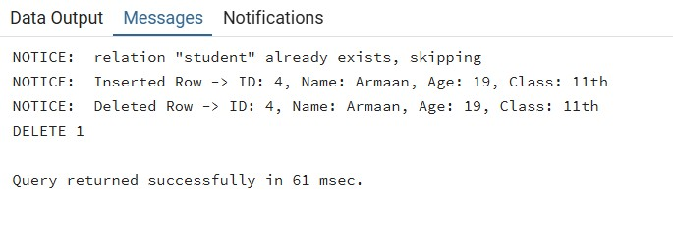

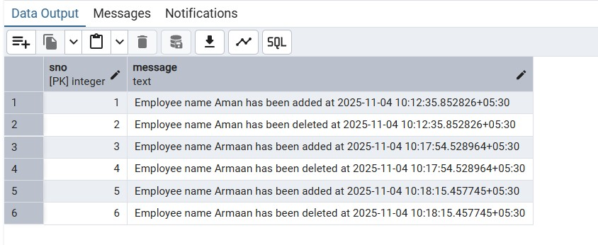

- Learning Outcomes:

  - Explain what PostgreSQL triggers are, when they fire (INSERT, UPDATE, DELETE,
TRUNCATE), and how timing types (BEFORE vs AFTER) affect behavior and use cases.
  - Implement PL/pgSQL trigger functions that correctly use TG_OP along with NEW and OLD records to access row states for different events.
  - Create and bind row-level triggers to tables using CREATE TRIGGER with the proper timing, events, and FOR EACH ROW vs FOR EACH STATEMENT semantics.
  - Build practical auditing solutions: emit RAISE NOTICE messages showing affected row data, and persist human-readable audit logs to an audit table on INSERT and DELETE.
  - Enforce business rules with BEFORE triggers to validate or block operations, and use RETURN NEW/OLD or NULL appropriately to allow or prevent changes.
  - Test and troubleshoot triggers end-to-end, including verifying NOTICE visibility and confirming audit entries after DML operations.

